Irena Vladimirsky
Socialist Realism in Russia
Socialist Realism was a term used to characterise the state of art and literature in the USSR during the 1930s-1950s. Socialist Realism was defined as a fundamental method of socialist art, literature and criticism that demanded from artists a ‘truthful and a historically real representation of socialist reality in its development’. Truthfulness and a historical reality of socialist life as reflected in art was intended to help in educating of Soviet citizens in the spirit of the revolutionary socialist-Marxist ideology.
The official definition of Socialist Realism was accepted by the First Congress of the Soviet Writers in 1934. First steps towards the new socialist art were undertaken during the 1920s with the establishment of the Association of Revolutionary painters and VKhUTEMAS (Higher Art-Technical Workshop). New Art associations required that their members show everyday life of ordinary citizens of the new social order: workers, peasants, Red Army men, party and Soviet leaders and Bolshevik revolution heroes.
Since 1934, Socialist Realism was defined as the only form of art creation and became the official guideline for art and literature and the sole criteria by which the validity of any literary or art creation was appreciated. From then on, art and literature were regarded solely as instruments of Communist propaganda. They were intended to reflect, or to describe, the brighter sides of life under Communism. Socialist Realism was accepted as the only officially accepted form and non-socialist realist art and literary works were rejected by Communists as the expression of bourgeois decadence.

Socialist Realism was based on three main principles. First was a national character that was intended to make art understandable to ordinary citizens, such as workers and peasants. The second was to connect art images to proper ideological content. Artists were expected to show the peaceful everyday life of Soviet citizens, heroic deeds of workers, peasants, and soldiers involved in the construction of a new and improved society for humanity. The third principle was the principle of actuality. Artists were required to be objective in their descriptions of everyday reality in its historical development, following the requirements of a materialistic understanding of history and class struggle of working people for a better life. According to Marxist postulates, changes of existence determine changes in consciousness and the vision of existing reality.
Realism was defined as the basic method of socialist art. Socialist realism was expected to use the heritage of world realistic art, connect art works with everyday reality and make art a mirror of socialist transformation of society. Every artist was required to demonstrate an understanding of socialist reconstruction processes in their dialectical development and interaction. The main emphasize was placed on positive heroes, true builders of a better society and Communist paradise on earth.
The Communist Party and the Soviet State limited art to narrow frames of strictly defined rules and restrictions and implemented administrative sanctions against unwilling tendencies in art, literature and architecture. Distinguished artists were encouraged by creative commissions provided by the All Union Houses of Art Work at the outskirts of Moscow or on the shores of the Black Sea. Party and Soviet authorities took responsibility for organization of art exhibitions and provided necessary living conditions for the Soviet artists. Freedom of art creativity was confined to technical methods of painting and choice of the color palette. Party and Soviet organizations became the main customers of Socialist Realism paintings and sculptures. Works of Socialist Realism were mandatory in every public place, party and administrative building, school, kindergarten and hospital.
Isaac Brodsky (1883-1939), a student of Ilya Repin should be mentioned among outstanding representatives of Socialist Realism. He was known for his gallery of portrayals of Soviet and party leaders, mostly Vladimir Lenin and paintings dedicated to the events of the Bolshevik Revolution and the Russian Civil War. Alexander Samokhvalov (1894-1971) was famous for his universal art craft. He was known for his paintings, watercolors, graphics, illustrations, sculptures and teaching. His favorite subject was Soviet youth. Alexander Deineka (1899-1969) was a painter, graphic designer and sculptot. His paintings depict scenes of sports and labor events. His set of mosaics became the decoration of Maykovskaya Metro Station in Moscow which was opened in 1938. Pavel Korin (1892-1967) was born to the family of an icon-painter, was a student of Mikhail Nesterov and Konstantin Korovin and was known for his monumental paintings (Alexander Nevsky) and restoration work. Dmitry Nalbandyan (1906-1993) was given the nickname of "the first paint brush" of the Communist leadership, mostly for his portraits of Josef Stalin and his close surroundings.
Socialist Realism became a fundamental art principle in the countries of Eastern Europe (Romania, Bulgaria, German Democratic Republic, Hungary, Poland) and Far East (China, Vietnam, North Korea). Socialist Realism became a substitute for existing reality. In the place of true reality the artists offered a myth of an imaginable reality as envisioned by the Communist dream.

References and further reading
Bown, M. (1991). Art under Stalin. New York: Holmes & Meier Publishers
Bown, M. & Lanfranconi, M.(2012). Socialist Realism: Great Soviet Painting 1920-1970. Milano: Skira
Clark, K. (2011). Moscow, the Fourth Rome: Stalinism, Cosmopolitanism, and the Evolution of Soviet Culture. Cambridge: Harvard University Press
Gorky, M. & Radek, K.(1977). Soviet Writers' Congress, 1934: The Debate on Socialist Realism and Modernism. London: Lawrence & Wishart
Grays, B., Rougle, C. (2011). The Total Art of Stalinism: Avant-Garde, Aesthetic Dictatorship, and Beyond. New York: Verso
James, C., Vaughan, J. (1973). Soviet Socialist Realism: Origins and Theory. London: St. Martin's Press
Paperno, I., Grossman, J. D. (1994). Creating Life. The Aesthetic Utopia of Russian Modernism. Stanford: Stanford University Press
Prokhanov, G. (1995). Art Under Socialist Realism: Soviet Painting 1930-1950. New York: Craftsman House
Terz, A. (1982). The Trial Begins and On Socialist Realism. Berkeley: University of California Press

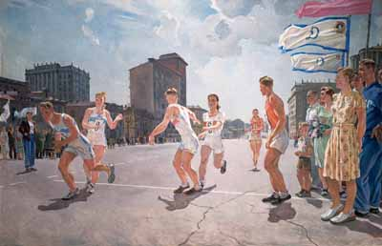
Alexander Deineka, Relay Race along the Garden Ring, 1947. Oil on canvas. 199 x 299 cm. State Tretyakov Gallery, Moscow
http://www.artpoisk.info/artist/deyneka_aleksandr_aleksandrovich_1899/estafeta_po_kol_cu_b

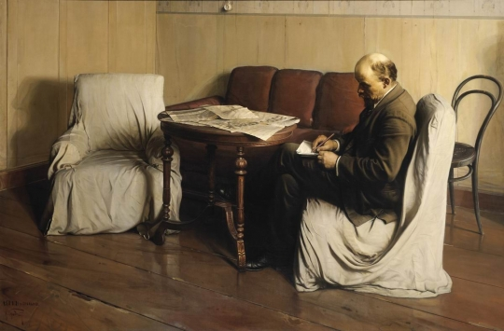
Isaak Brodsky, Vladimir Lenin in Smolny, 1930. Oil on canvas. 190 x 287 cm. State Tretyakov Gallery, Moscow
http://www.tretyakovgallery.ru/en/collection/_show/image/_id/331

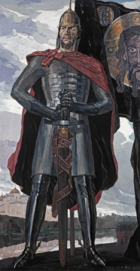
Pavel Korin, Alexander Nevsky, 1951. Oil on canvas. 101 x 72,5 cm. State Tretyakov Gallery, Moscow
http://www.tretyakovgallery.ru/en/collection/_show/image/_id/343

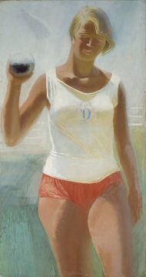
Alexander Samokhvalov, Girl with Shot, 1933. Oil on canvas. 124,5 x 65,8 cm. State Tretyakov Gallery, Moscow
http://www.tretyakovgallery.ru/en/collection/_show/image/_id/359

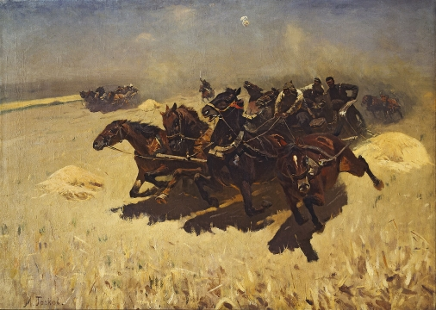
Mitrofan Grekov, Gun Cart, 1925. Oil on canvas. 83 x 114 sm. State Tretyakov Gallery, Moscow
http://www.tretyakovgallery.ru/en/collection/_show/image/_id/334

